CURRICULUM VITAE

|  |  |
| --- | --- |
| G.NAGARAJU  🕿 +91 9052988808  🕿 +91 9959288808  Email: nagarajreddygotukula@gmail.comPermanent Address G.Nagaraju  H.No.2-108/7/17/53, PLOT NO.-53  EAST VENKATREDDY NAGAR COLONY, BODUPPAL, HYDERABAD,  500092 | Career Objective :   * To strive and contribute towards the development of new technologies based on my experience In Markating develapments   Vision :   * To achieve heights to the best in the field in which I work to be a part of the organization in its success.   Academic profile :   * **M.B.A(Master of Business administration)**   Period : 2010 – 2012  percentage : 61.50%     * **Bachelor in Science** (Biotechnology,Chemistry   Computers)  Period : 2007 - 2010  Percentage : 73.67%   * **Intermediate**(Botany,Zoology,Physics,Chemistry   Period : 2004 - 2006  Percentage : 59.50%     * **S S C**   **Period : 2004**  Percentage : 83.58%  Experiences : HDFC BANK LTD IN FROM 01 FEB 2012 TO02 MAY 2013LIABILITY BRANCH CO-EX EXPERIENCEKOTAK MAHINDRA BANK IN 20 MAY 2013 TO JAN 21.2014 LIABILITY BRANCH BANKING IN ASSISTANT MANAGERYES BANK IN 04 APR 2014 TO TILL DATE LIABILITY BRANCH BANKING |

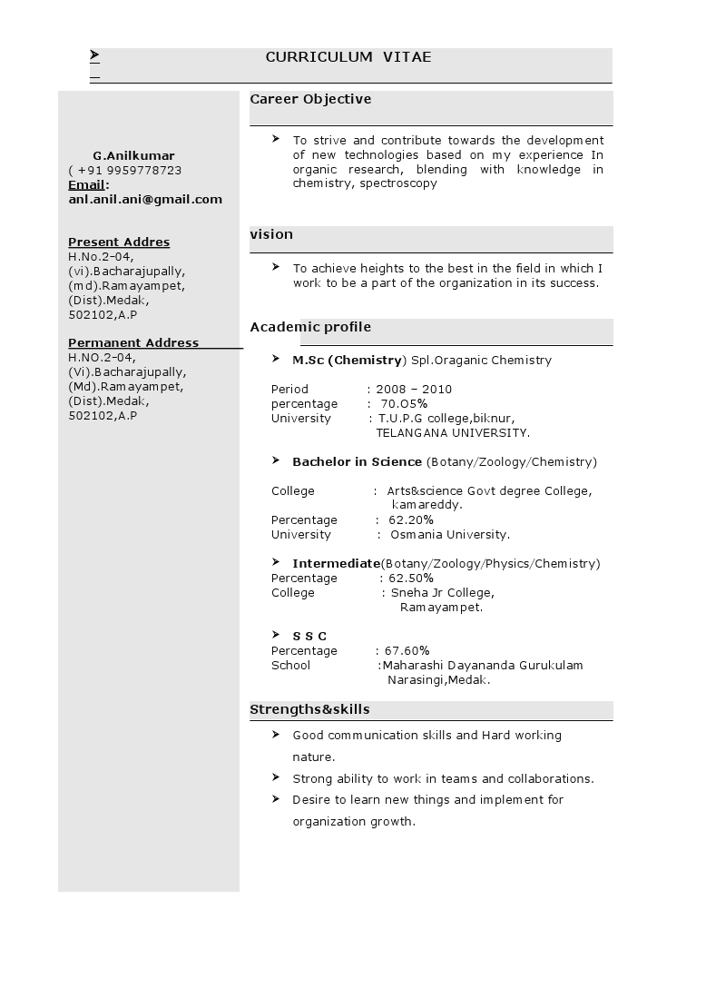

Work Profile:

#### Sourcing a Quality Savings and Current Accounts.

#### Cross sell of Life Insurance and Mutual Funds and

#### Home Loans and Mortigage Loans and Health Eqiupment Loans

#### 

Computer Skills :

* MS-Office,c language
* Internet Concepts, browsing

Personal Details :

Name : G. NAGARAJU

Father ‘s : G.YAKAIAH

Date of Birth : 10-04-1989

Sex : Male

Languages Known : Telugu,Hindi&English

Nationality : Indian

**Declaration :**

I here by declare that the above return particulars are true to the best of my knowledge and belief.

Date:

Place: Hyderabad. **(G.NAGARAJU )**